**MoH HIS Subsystems**

**System Context Diagram**

***Ministry of Health, eHealth Africa***

***April 2018***

|  |  |  |  |
| --- | --- | --- | --- |
| **Version** | **Author** | **Date** | **Note** |
| 0.1 | Qing Gong | 2017.12.27 | draft |
| 0.2 | Qing Gong | 2018.04.04 | Updated the diagram, included text descriptions |
|  |  |  |  |
|  |  |  |  |
|  |  |  |  |

Table of Contents

HIS Subsystems System Context Diagram

Descriptions of Systems and Contexts

Tools

## 

## HIS Subsystems System Context Diagram

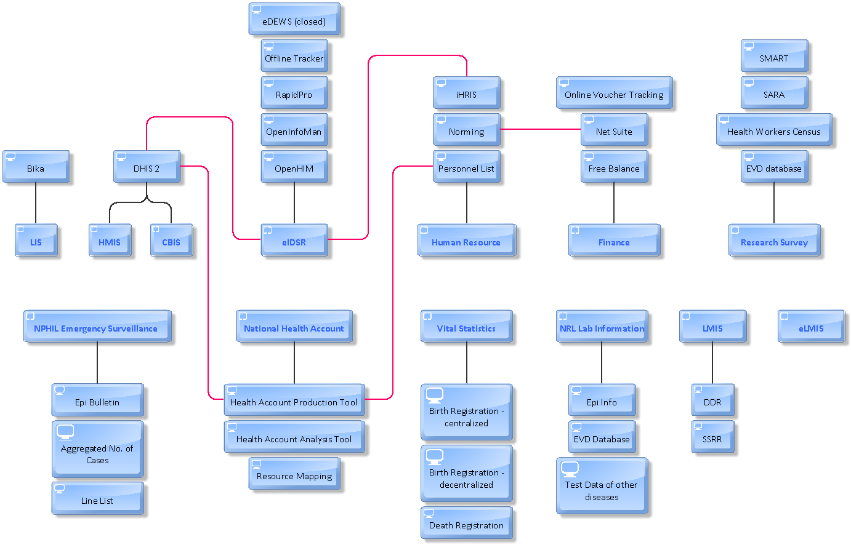

## Descriptions of Systems and Contexts

**DHIS2**: it is used as the Health Management Information System (HMIS) and Community Based Information System (CBIS)

**Bika**: it implements the Lab Information Management System (LIMS/LIS).

**eDEWS**: it is a disease early warning system managed by WHO and piloted in 4 counties. But due to its high cost, it is closed down now.

**Offline Tracker**: it keeps track of surveillance cases. The cases are stored in a separate instance of DHIS2 which is hosted by eHA now. The data are going to be transferred to MoH.

**RapidPro**: it is used to design SMS workflows. SMS messages are also stored here.

**OpenInfoMan**: is used to implement the InterLinked Registry (Health Worker Registry + Facility Registry), which acts as a gateway for getting data from iHRIS and DHIS2.

**OpenHIM**: it is used to implement the Interoperability Layer. It handles the transactions and has functionalities of authorization, authentication, etc.

Offline Tracker, RapidPro, OpenInfoMan, OpenHIM, together with DHIS2 and iHRIS forms the functionalities of eIDSR.

**Line List**: a line list in Excel is used in NPHIL to record the surveillance cases for 14 immediately reportable diseases and diseases of international concern.

**Aggregated No. of Cases**: aggregated No. of cases by week for the total year is recorded in Excel.

**iHRIS**: the Integrated Human Resource Information System is used to keep track of information about all health workers in Liberia.

**Norming**: it is a software system used to generate and manage Incentive Payrolls for health worker in the entire public sector.

**Personnel List**: it is an Excel sheet which contains information about health related employees on GOL payroll.

**SARA**: Service Availability and Readiness Assessment is a tool used to assessment and collect information about health facilities.

**Health Workers Census**: the Health Workers Census is composed of two parts. One part covers the health workers information, and the other part covers the health facility information.

**SMART Survey**: it asks about the nutrition status and mortality information of children.

**EVD Database**: it was established during the time of Ebola outbreak in Liberia in 2014. It keeps information about the Patients and Contacts (probable case, suspect case, simple sign and symptom case, confirmed case).

**NetSuite**: it is a financial management system used by MoH. Information of all transactions in MoH are captured in NetSuite. It is integrated with Norming.

**Online Voucher Tracking**: this online system is hosted by the Ministry of Finance. It is used to produce vouchers.

**Free Balance**: this system is hosted by the Ministry of Finance. It is used to produce vouchers and generate voucher number.

**Health Account Production Tool**: it is a system used by the Health Financing Unit to track health sector expenditure over 1 fiscal year. Information from DHIS2 and Personnel List are used in this tool.

**Health Account Analysis Tool**: it is a system used to do analysis based on the data collected in the production tool. Analysts use the charts, graphs, etc. generated by this tool to write their reports. Data are not stored in this tool.

**Resource Mapping**: it is an Excel tool used to keep information about potential expenditure for planning purposes.

**Centralized Birth Registration System**: a centralized birth registration system based on Access database is used at the birth registration data office mainly for birth registration of adults.

**Decentralized Birth Registration System**: a decentralized birth registration system for Children of 0-12 years old is introduced in year 2017 for birth registration at the facilities. The plan is to migrate the centralized system to the decentralized one. In the future, only the decentralized birth registration system will be used, for adults and children.

**Death Registration**: one partially developed death registration system is used to generate Death Certificates. Death registration related information are stored in Excel sheets.

**Test Data**: Different Excel sheets are used to store lab test data for different diseases.

**EVD Database (NRL)**: an Access database is used to store Ebola related test data.

**Epi Info**: this system is used for weekly reporting to WHO regarding Measles and Yellow Fever cases.

**DDR**: as part of the Logistic Management Information System (LMIS) used by the Supply Chain Management Unit, Daily Dispensing Register (DDR) is an Excel tool that captures monthly consumptions of drugs or medical supplies

**SSRR**: as part of the Logistic Management Information System (LMIS) used by the Supply Chain Management Unit, Stock Status Report and Requisition (SSRR) is an Excel tool that captures quarterly stock balance and requests.

**eLMIS**: it is a electronic Logistic Management Information System introduced in 2018 to replace the LMIS tools.

For more details of the HIS subsystems and its data collection processes, please refer to [MoH HIS Subsystems Inventory and Data Collection Processes](https://docs.google.com/spreadsheets/d/1M5xFD1M3-9w-dkfk4ej3rbNP6DP81MxTb7SgOfmeALo/edit?usp=sharing).

## Tools

The tool that is used to create this System Context Diagram is ARIS Express. It’s an easy to use tool that can be downloaded and used free of charge.